Assignment 1
Research into AI Ethics & Responsible AI

Authors
Alex Vrsecky 104268899

Version History

Version | Sections Updated | Updated by

Statement of Contribution

Name (Student No.) | Contribution | Signature
Alex Vrsecky (104268899) | Report | ALEX VRSECKY

Table of Contents
Version History 2
Statement of Contribution 2
Table of Contents 3
Introduction 4
Body 4
Subsection 1 4
Conclusion 4
References 4

Executive Summary

https://apnews.com/article/israel-palestinians-ai-technology-737bc17af7b03e98c29cec4e15d0f108
By MICHAEL BIESECKER, SAM MEDNICK and GARANCE BURKE
Updated 11:06 PM GMT+11, February 18, 2025

https://www.theguardian.com/technology/2025/feb/05/google-owner-drops-promise-not-to-use-ai-for-weapons?utm_source=chatgpt.com
Lenore Taylor
Editor, Guardian Australia

Introduction

The ethical question of “should AI systems be allowed to kill” is a widely debated topic and branches into complex moral and ethical issues. The question is centred around a idea that has been long considered deeply wrong. Many argue that the development of such systems will trigger a dangerous global arms race; similar to the US – USSR Nuclear arms race. If these systems are developed, we need to consider that terrorist organisation, or groups involved in ethical cleansing could obtain these technologies creating national security risks. Conversely banning the development of these AI systems might be unrealistic, due to the massive amount of industry investment. Arguments have been made that the inevitable development of these system, may lead to less loss of life, due to military being able to pull out human soldiers in replacement of these AI systems. Arguments in support of AI soldier robots convey that to their programmatic nature they will be more adept to adhering to laws of war and the rules of engagement.

While researching I have taken the Deontology approach with the principle of killing is wrong, but have taken in consideration the utilitarianism view that killing is inevitable, and in that case what are they best approaches we can use to develop AI systems designed to kill. The scope of this report only covers the AI systems that do not have complete autonomy and always have a set of pre-determined rules made by man.

Findings

Subsection 1
The problem is represented visually as Figure 1….
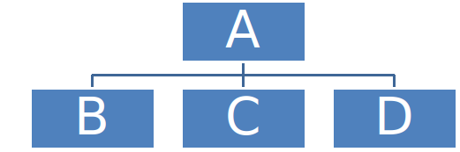
Figure 1: Random block diagram

Conclusion

References

